

Design and develop an online application for retail

Research Project Report



Spring Semester, 2017

This Project is submitted in partial fulfilment of the requirements of the “Univisity of technology, sydney” for the degree of master information technology

By

Kunanon Pititheerachot

12634123

Supervised by Dr. Helen Lu

and

Co-Supervised by Dr. Gouhua Liang

Table of Contents

1. Abstract 2

1.1 Keywords 2

2. Introduction 3

3. Problem Statement 4

4. Literature review 5

4.1 The definition of Recommendation System 5

4.2 Overview of Recommendation System 5

4.2.1 Collaborative Recommendations 5

4.2.2 Content Based Recommendations 6

4.3 Literature Review Summary 6

4.3.1 Collaborative recommendation method 6

4.3.2 Content-based recommendation 7

4.3.3 Conclusion 7

5. Research Methods 8

5.1 Methods of Design 8

5.1.1 Tools and Instruments 8

5.1.2 Design Implementation 8

5.2 Method of Development 13

5.2.1 Tools and Instruments 13

5.2.2 Development Implementation 13

5.3 Method of testing 19

5.3.1 Tools and Instruments 19

5.3.2 Testing Implementation 19

6. Results of testing and Discussion 24

7. Conclusion and Future Work 25

7.1 Conclusion 25

7.2 Future Work 25

Reference List 26

# 1. Abstract

In this research project report propose a recommendation system which is using content-based recommendation method in order to develop an online web application for retail. This content-based recommendation method uses content from the individual user’s latest interest in order to provide precisely product recommendation. The recommendation system evaluates the user’s latest purchase history. In this project also enhance capability of content-based recommendation system by augment the uses of content that the system will focusing on recommend the high rating products in order to increase the chance of sale. From these two combinations will increase the accuracy of the recommendation and more efficiency than only use of content-based system.

## 1.1 Keywords

Content-Based Recommendation Method; Recommendation System; Content-Based Filtering System;

# 2. Introduction

Rise of internet has rapidly grow up every day around the world also service on internet including online educations, entertainments, social networks, communications, including shopping. Online shopping is one of the most popular online service that everyone uses it now a day. This kind of online business has rapidly increasing growth rate as we can see some of giant ecommerce website such as Amazon, eBay, Alibaba have expanded their services and products continuously. These online retailers are growing bigger and bigger in every area of their own services and which means they are providing more choices of products to their customer in order to satisfy their audiences. The recommendation system is one of the most essential technique for online retailers that it provides suitable and properly service which help both customer and seller to reach their own goals.

As mentioned before that these online retailers are growing up every day with massively number of product which means more information on their website is becoming burden and could be obstacle the customer to reach their desire product. In addition, customer might not want to dive into web application with a hundred thousand of product and they do not know is the product is useful so it might make customer curious and feel uncertain to buy it. Moreover, customer need something that could help them to consider the most worth their money. In generally, a lot of users guided by widely type of factors such as another feedback, reviews, ratings, recommendation from someone or randomly from the system. In real world before people use online application for shopping we also use some factors in order to make a buying decision for instant “my friend tell me about his shirt is well tailored and suggest me to buy one”, “in the retail shop sometimes we buy shoes because shop assistant says this one is the best seller”, or “sometimes when we go to the same restaurant and waitress is remember what we always order she might ask if we want the same thing as usual”. So, online retailers are using these common factors in same way as it already well known.

The recommendation system in this research project will use factors or contents from customers which is based on purchase history and amplify with product rating from other customers that bought it before in order to provide precisely product recommendation. This content-based recommendation method in the research project web application is able to recommend the items that the customer might interest to buy it by using customer’s purchase history and evaluate the small group of products by filtering only highly ratings and number of product sales products to represent to customer screen. Note that if the customer is come for the first time or never bought anything from this web application before the recommendation would consider the highest number of product sale and following by best rating. In addition, in this project implementation with limited amount of experiment resources such as products, ratings, users, etc.

# 3. Problem Statement

Rapidly increasing of information amount on internet cause data overload effect which means the online information now a day has too much and burden the online services quality and speed. This information overload situation cause obstacle to internet user and retailers directly as mentioned before which means online retailers could possibly drop down their average services and internet user could reach their product slower or not get what they are looking for because loads of unnecessary information.

One of the most effectively technique that able to solve information overload is “Recommendation System”. This recommendation system uses for providing recommendation to online customers in order to assist them to reach what product they are looking via online shopping. Recommendation method provides service by calculate the result based on data in retailer database such as user’s purchase history, preferences, profiles, product ‘s details and rating. This technique has a several number of methods, and the two major methods that provides efficiency use are collaborative recommendation method and content-based recommendation method.

# 4. Literature review

## 4.1 The definition of Recommendation System

Recommendation system or recommendation engines is used for provides accurately suggestion products that relate to customer interest by using simple algorithms to filter the massively data from database such as customer’s purchase history (Bansal, 2015).

Moreover, recommendation systems are made use of data analysis which means the recommendation is provided after a huge analyzed data then transfer only useful information from database to recommendation systems in order to provide accurately suggestion in widely range of application type such as entertainment, news, books, and goods, etc. Normally, Recommendation system has two major methods which are content-based filtering and collaborative filtering that working differently to each other depends on type of application (Mathew, Kuriakose & Hegde 2016).

Furthermore, recommender system is used in widely type of services such as movies, music, books, goods and etc by using user’s history. Recommender system has various type of methods which are the two most well-known content-based and collaborative, demographic, knowledge-based and etc (Uddin, Shresth & Jo 2009).

In addition, recommender system is one of the most important online application for web usage. Recommender system aim to produce result by using user’s habit and assist user through reach what they are looking for on the website. Recommender algorithm initiates when user browsing in the website then user’s histories will be stored as a web log (Tyagi & Jawdekar 2016).

## 4.2 Overview of Recommendation System

### 4.2.1 Collaborative Recommendations

Collaborative filtering method provides suggestion service which aim to recommend the products based on similarity of data indicator between items and like-minded users which means the system is recommended the products to the user based on another user that has similarity of purchasing history (Shaikh, Rathi & Janrao 2017).

Similarly, Collaborative filtering approach’s algorithm is the system apply filter to database by using user’s rating or feedback from users purchasing histories on specific item. Collaborative method could assist provider to forecast the user’s area of product that user would like to purchase (Mathew, Kuriakose & Hegde 2016).

What’s more, the concept of collaborative filtering method is based on similar users that has same interest in the selected products. This method provides recommendation by using algorithm that compute the result based on data between similar users and their purchasing history. The majority features of this method are users feedback then apply filter to their large number of products list and have a little bit focusing on their products metadata preparation (Sato, Fujita, Kobayashi & Ito 2013).

Furthermore, collaborative is one of the most powerful enhancement for e-commerce now a day. Collaborative system implements the services based on products rating or feedback, and matching between users that has the similarity area of purchasing products then produce the suggestion to the users. This method is providing powerful efficacy in researching and practicing (Hsiao & Li 2014).

Moreover, collaborative filtering or CF is the recommending system that uses rating of products in the database as a main information in order to produce the suggestion to user by comparing between products’ rating in the similarity type of users. This method is working by keep expanding their data including product data, rating, and user which is connect to each other then uses this data to provide result back to another user that has the same interest (Uddin, Shresth & Jo 2009).

### 4.2.2 Content Based Recommendations

Firstly, content based recommendation method recommends products by using algorithm that regarding to another data product such as well-known company like Amazon that provides recommendation product based on content of user’s purchasing history like if user bought some romantic books then the system will filter the data from database and recommend some more romantic genre books that user has not bought yet (Shaikh, Rathi, Janrao, 2017).

Secondly, content-based filtering algorithm compute information based on user’s preference. This algorithm is required to set each data in database to have uniquely data. This method’s priority is focusing on user’s preferences and purchase history, by compute individually for each products data and user’s selection. Major feature of this method is the system able to calculate the unique product’s data from database, but the limitation is that it can be used for small amount of user’s purchase history (Sato, Fujita, Kobayashi & Ito 2013).

Thirdly, content-based recommendation diagnoses the data information from the database, by choosing data information based on similarity of contents which are including product’s details, product’s description, and product’s titles then considers the suitable products for user and provides recommendation products (Hsiao & Li 2014).

Moreover, content-based or CB provides suggestion to users by using comparison method that compare between each product’s contents that user likely to purchase. Normally, this content-based recommendation method will need some other methods in order to reach the maximum performance (Uddin, Shresth & Jo 2009).

What’s more, normally content-based recommendation technique produces results based on comparison between the product’s contents and user’s preferences. Information of user’s preferences are stored in database and used for calculating the recommendations by using their purchase history to provides accurately product that user may interest (Hirooka, Terano & Otsuka 2000).

## 4.3 Literature Review Summary

Recommendation system is one of the best method that currently solving information overload issues. As mentioned before recommendation system has several methods type that has differently algorithms and results. For most popular and clearly effective methods are collaborative recommendation method and content-based recommendation method. These methods are suit online application for online retailers but depends on which function able to produce best effect to user.

### 4.3.1 Collaborative recommendation method

Collaborative recommendation method is mostly using for website that has rating and feedback after customer purchase the products from the website. The major indicator will be rating and feedback information that must available in online retailer database. Then the system will use these rating of the product to calculate and provide result to the users that has the similar taste by consider from their purchasing habit and purchase history.

The advantage of the collaborative recommendation method is able to provide service to big size of website data, provide more precise recommendation to specific group of people that has the same interest and it suitable for web application that has a lot of products

The disadvantage is on web application that might need to develop more function to gain user preferences, need more complicate function to calculate the recommendation between each user preference, and it not suitable for small business that has less number of products and users.

### 4.3.2 Content-based recommendation

On the other hand, content-based recommendation method provides services by calculate the measurement of product’s area and comparing between product’s detail and user’s preferences and purchase history. The main key is this method only need user’s preferences data in order to suggest precisely product to them. This method obviously uses information to compute the recommendation result less than collaborative method.

The advantage for using content-based recommendation is more useful when apply to small size web application which is provide more speed and less complicated when compare to collaborative recommendation method because content-based recommendation only need user purchase history in order to produce recommendation and also calculate the recommendation in each user which mean it has more accuracy recommendation to individual user because the information is based on individual user’s purchase history.

The disadvantage is that content-based method is not suitable for using on the giant size web application because it is provided the recommendation by using individual history which mean it has to use the whole history from the user and calculate as an individual information it will cause a lot of burden to the system and slow the web application service down.

### 4.3.3 Conclusion

In conclusion, different recommendation methods use differently indicator in order to produce the result for suggestion such as collaborative need an extra user’s feedback information and content-based recommendation method normally uses data from database and user’s preferences. As a result, these methods assist internet user to achieve what they need and solve the information overload issue and decrease obstacle on the internet at the same time, although the processing might different depends on goals and size of the online retailers but clearly these major methods are the some of the most efficiency ways to solve every internet users’ issues.

# 5. Research Methods

In this research will be developing online web application for online retailer focusing on content-based recommendation effective method to solve the information overload issue that cause the obstacle to internet user. The project will be qualitative research approach, and apply methods that online application prototype is required such as content-based recommendation method, visualization of order processing, and online payment method.

## 5.1 Methods of Design

### 5.1.1 Tools and Instruments

In order to illustrate cursory my idea I roughly draft my web application prototype appearance I chose the simple application such as Microsoft Exel to create list of database tables and fields, and website application which called <https://www.gliffy.com/> to create the firstly image and design simple diagram for web pages and database of my research prototype.

### 5.1.2 Design Implementation

Firstly, I create list of significant page that retail’s web application would be used and mapping the relation between pages, which is including in following list:

* Homepage
* Register Page
* Login Page
* User Account Page
* Admin Zone Page
* Catalogue Page
* Product detail Page
* Cart Page
* Delivery Address Page
* Checkout Page
* Payment method Page
* Confirmation or Receipt Page
* Etc.

Secondly, after list was created I create simple diagram (Figure 1). for web appearance which based on the list by using online web application to illustrate my idea and roughly relation and process between each page of my website

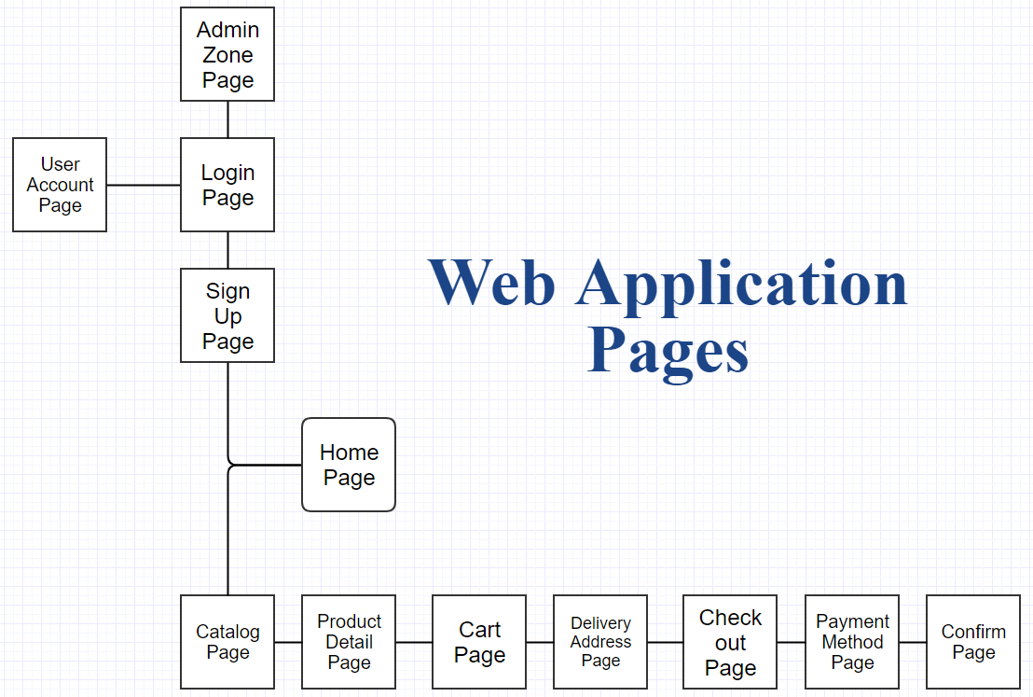

Figure 1: Web Application Pages Diagram.

Thirdly, design web appearance template according to web application pages diagram that created before to illustrate appearance of each web page that illustrate below in Figure 2 which is including navigation bar at the top that including buttons such as Home, Account, Cart, and Sign up/ Sign in/ Sign out in every page, and main content for each page should cover 80% of page’s space, also need footer at the bottom in every page for copyright details and etc. with back to top button.

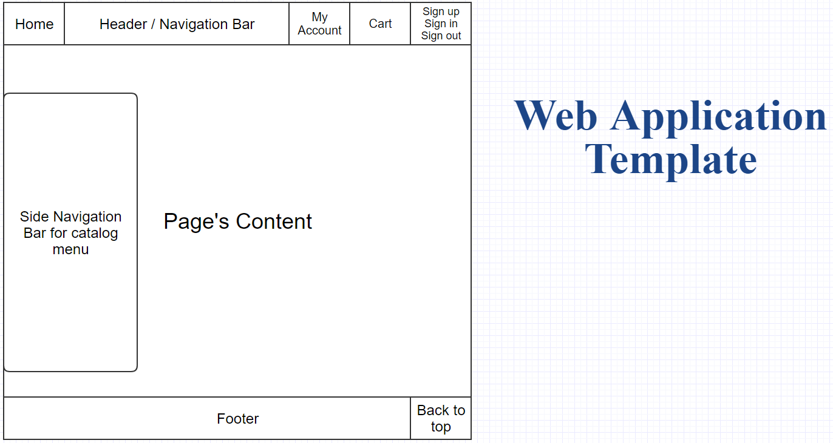

Figure 2: Web Application Template.

Finally, for the design stage it should also has design of database in order to scope the data that essential to the prototype. Before design the database diagram I list all the tables, fields, and type of information that would be used in the prototype’s database which is list below (Figure 3):

|  |  |  |
| --- | --- | --- |
| Table | Field | Type |
| Category | Category ID | integer |
| Category Name | varchar |
| Description | varchar |
|  |  |
| Customer | Customer ID | integer |
| Username | varchar |
| Password | varchar |
| Customer First name | varchar |
| Customer Last name | varchar |
| Customer Address 1 | varchar |
| Customer Address 2 | varchar |
| City | varchar |
| State | varchar |
| Postcode | varchar |
| Country | varchar |
| Customer Tel | integer |
| Email | varchar |
| Privilege ID | integer |
|  |  |
| Customer Privilege | Privilege ID | integer |
| Privilege Description | varchar |
|  |  |
| Order Cart | Order ID | integer |
| Customer ID | integer |
| Order Number | integer |
| Payment ID | integer |
| Order Date | datetime |
| Paid | varchar |
| Payment Date | date |
|  |  |
| Order Detail | Order Detail ID | integer |
| Quantity | integer |
| Order ID | varchar |
| Price | float |
| Product ID | varchar |
| Product Name | varchar |
| Product Image | text |
|  |  |
| Orders | Order ID | varchar |
| Customer ID | integer |
| Order QTY | integer |
| Order Total | float |
| Payment Type | integer |
| Order Date | datetime |
| Shipping First Name | varchar |
| Shipping Last Name | varchar |
| Shipping Address 1 | varchar |
| Shipping Address 2 | varchar |
| Shipping City | varchar |
| Shipping State | varchar |
| Shipping Postcode | varchar |
| Shipping Country | varchar |
| Shipping Email | varchar |
| Shipping Tel | varchar |
|  |  |
| Payment | Payment ID | integer |
| Order ID | varchar |
| Payment Type | integer |
| Payment Amount | varchar |
| Card Name | varchar |
| Card Number | varchar |
| Card Expire | varchar |
| Card Verify | integer |
|  |  |
| Payment Type | Payment Type | integer |
| Payment Type Description | varchar |
|  |  |
| Product | Product ID | varchar |
| Product Name | varchar |
| Product Description | text |
| Category ID | integer |
| Picture | text |
| Price | integer |

Figure 3: List of Information used in Database.

In addition, implementation of prototype web application database diagram is based on figure 3 list above which illustrate as figure 4 below to represent the relation between each database that including name of each table and fields also provides the PK stand for Primary Key for each table.

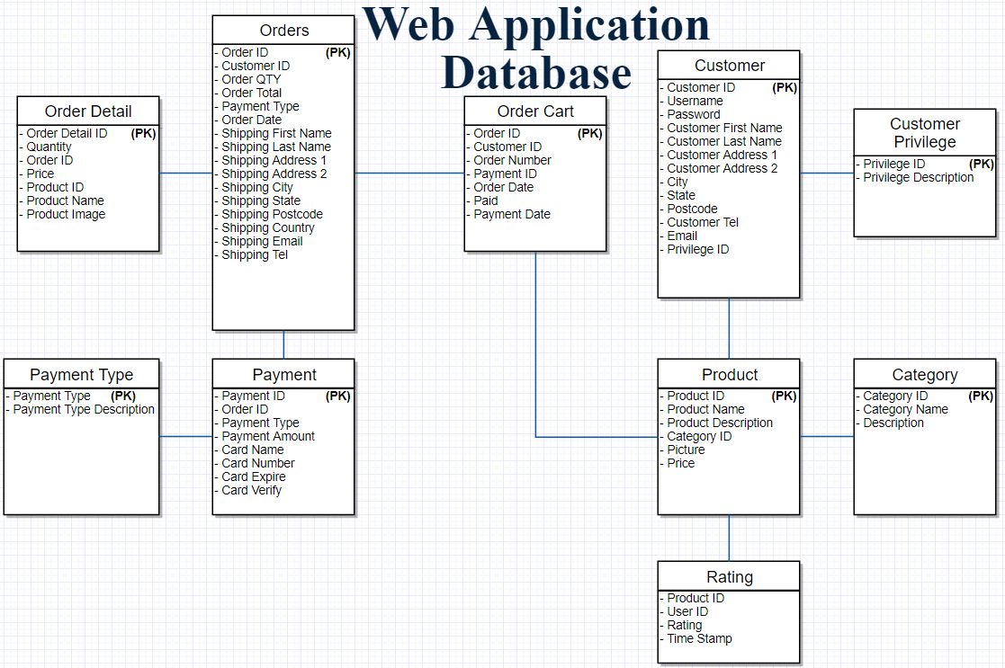

Figure 4: Web Application Database Diagram.

As a result, from this design stage I obtained following diagram and information:

* Web Application Pages Diagram (Figure 1),
* Web Application Template (Figure 2),
* List of Information used in Database (Figure 3),
* Web Application Database Diagram (Figure 4).

In the next stage of research method will be development and implementation stage which is carry on research based on this design solutions.

## 5.2 Method of Development

In this research project require modern text editor for code editing, PHP framework, visualization database application, information management application for database, computer with Microsoft operating system, apache and MySQL server, and etc. that will be combine together to gain a properly workflow.

### 5.2.1 Tools and Instruments

Firstly, text editor application I use ATOM from <https://atom.io/> website which is professional text editor, it is open source application and has a lot of open source packages to use which I think it would be perfect of use in order to implement the prototype. In this project will be implement web application based on PHP programming language, I think it would be efficiency if use PHP framework to implement the prototype. One of the most popular PHP framework is called CodeIgniter or CI, this CI framework is a beginner friendly and powerful PHP framework that come with cart library which is one of the major function for online retail web app and several built-in libraries that suitable for prototype development which can be download from <https://codeigniter.com/>. In order to manage the big amount of data information in database I choose to use visualization application which help me to see full picture of database and easy to manage some element such as table, fields, information type, and etc. And I use application called Navicat from <https://www.navicat.com>. In addition, I also use Microsoft Excel to create the information before import all information to the database. Moreover, to store database it requires MySQL server and also apache server for test prototype in this stage which I use XAMPP from <https://www.apachefriends.org/> to create a simulation of server on my computer. These tools are able to run on Microsoft operating system.

### 5.2.2 Development Implementation

In CodeIgniter framework, it is required some configuration in order to allow my prototype access to apache and MySQL server which is require configuration in the config folder:

* Base URL for testing in this development stage.
* Database URL and confidential to allow prototype to connect with the database.

And set up database with essential information that design before in method of design.

Next step approach, I start the development stage from homepage and continue to the customer’s account side first according to upper side in figure 1 from design method that require me to develop three parts for each web application pages which are client-side page called views page in CodeIgniter, server-side page has two type of pages files which are controllers and models. In view pages will be the representation of the prototype, controllers will be get input request from the views then if it require to the result that store in the database controllers will send require to models to get the data from database and send it back to controllers first and pass it through views, these combination between view, controller, model also known as MVC workflow. In view pages mostly use HTML language combination with JavaScript and CSS such as Bootstrap and awesome font files. On the other hand, in controllers PHP and models use SQL query in order to communicate with database.

In addition, it means in each web application page it will be using three files and different type. For instant, in homepage of the prototype it requires view to represent the homepage appearance look like illustrate below (Figure 5).

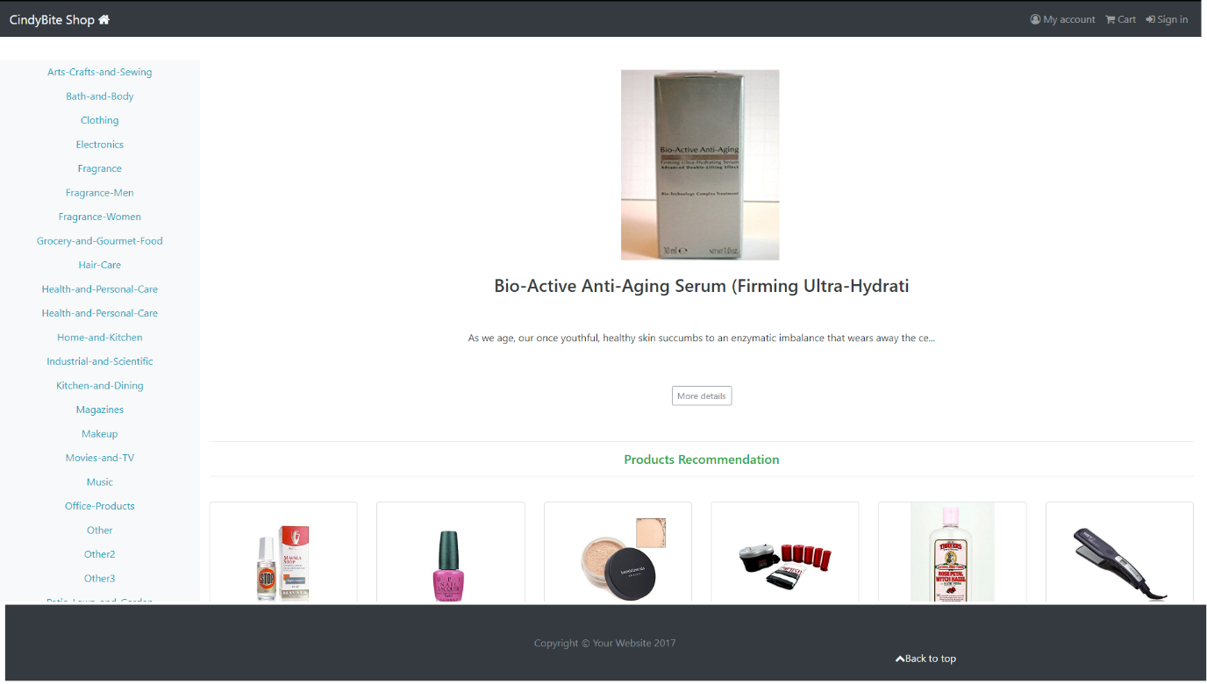

Figure 5: Example of Homepage.

In addition, this view is a result of PHP file that contain a HTML, CSS, JavaScript language (Figure 6).

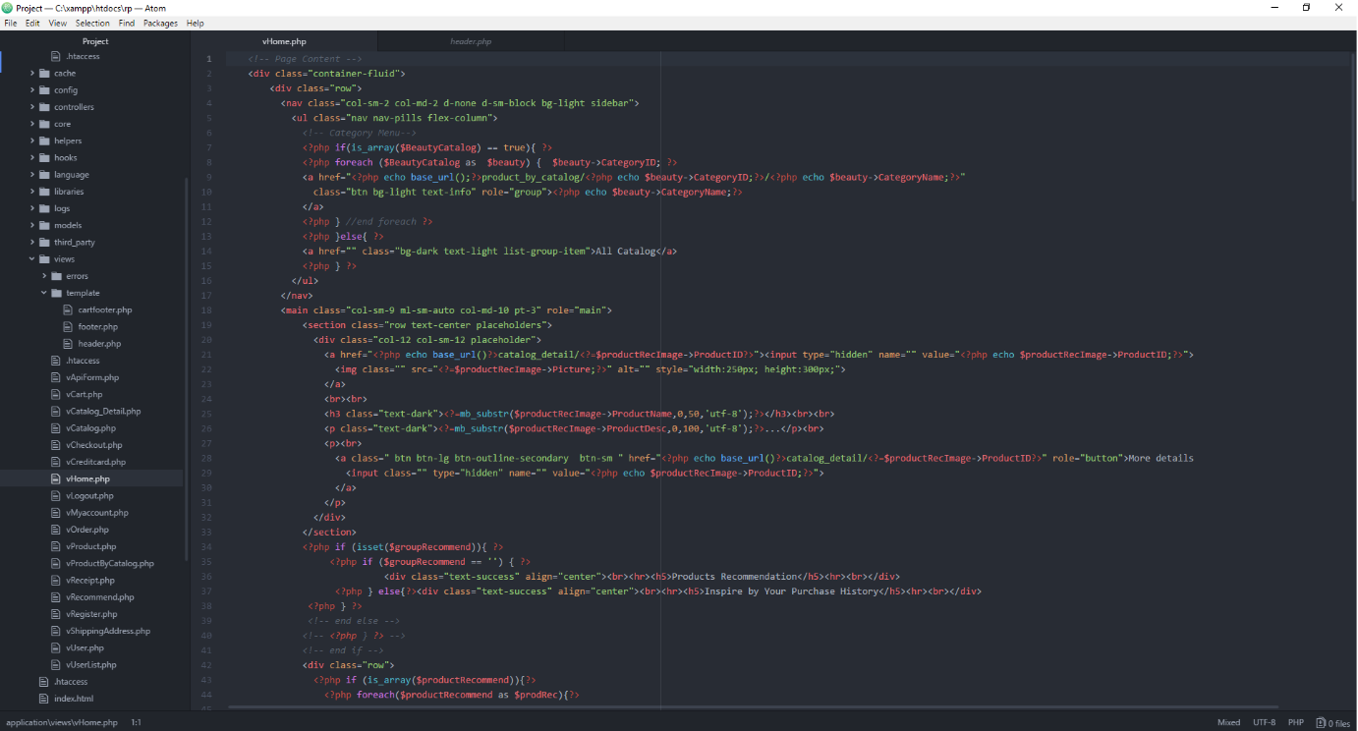

Figure 6: Example of Homepage View File Named “vHome.php”.

Moreover, this view of homepage will be only representing the appearance without functionality which require the controller file (configure 7) to provide services such as link the menu button to another page.

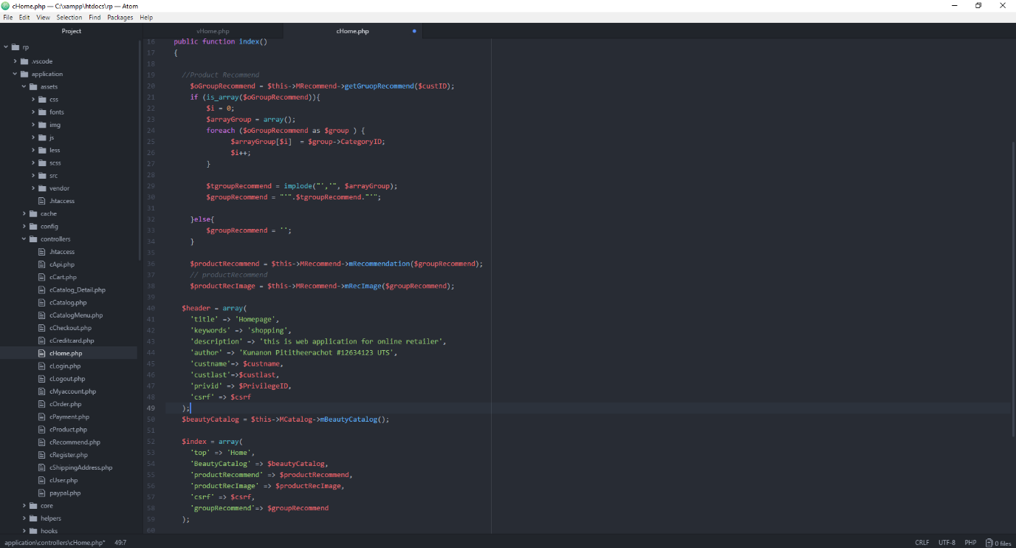

Figure 7: Example of Homepage Controller File Named “cHome.php”.

And it would require the information from database to represent such as products, catalog menus, access to user information, etc. by working with model file and use MySQL query code and PHP, for example of request the catalog menu from database has shown in figure 8 below.

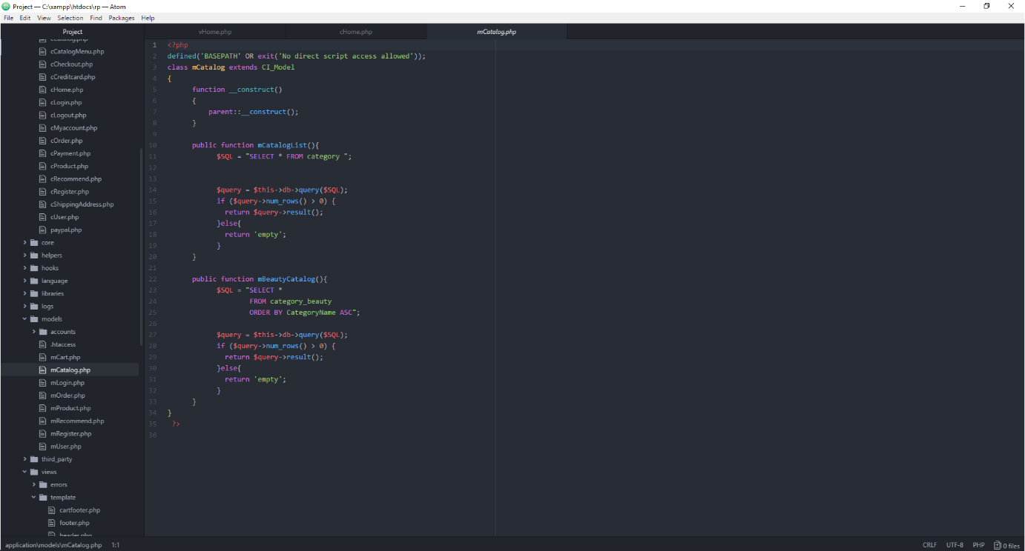

Figure 8: Example of Catalog Model File Named “mCatalog.php”.

In this prototype I applied this MVC workflow to every page and connect between page by create route for them in “route.php” file in config folder adapt of this method depends on each page requirements and specific algorithm such as visualization of order in cart page which is used built-in library called “Cart library”, online payment method which require to connect the online service such as PayPal.

Recommendation system in this research project is using content-based recommendation which is use latest purchase history of individual customer in order to provide recommendation products and in addition with user’s rating to provide more accuracy recommend product which aim to increase more chance that customer will reach the product they desire to buy. In order to implement the recommendation system, the system will require purchase history from customer then the algorithm start with the MySQL query statement that looking for “Category ID” of latest product that customer purchased then find other products in the same category then limit with only amount that would need to show and only highly average of user’s rating would be picked to represent to customer in Homepage. In addition, in each category page will represent the highly average rating products that based on most number of user’s rating at the top of the screen. On the other hand, if customer has never purchase anything before the system will use the similar algorithm but only find the product with high number of user’s rating and high average user’s rating. For instant, as mentioned before the algorithm start with MySQL query statement to looking for category of the product from customer’s purchase history by using Customer ID (Figure 9).

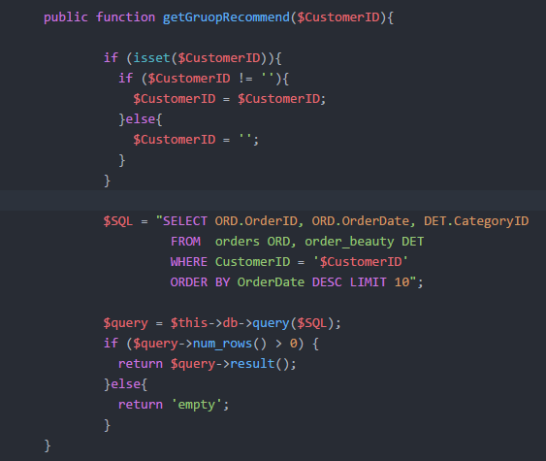

Figure 9: MySQL Statement and PHP Code for Getting Category ID.

After system has Category ID of latest purchase then return result to controller and send Category ID to another model function that will use this Category ID to find other product by evaluate the factor such as number of user’s rating, average of rating which only five-star rating will be return, and limit only twelve products (Figure 10). And the result will be returned to controller file and pass to view page in order to represent the recommendation product as Figure 11.

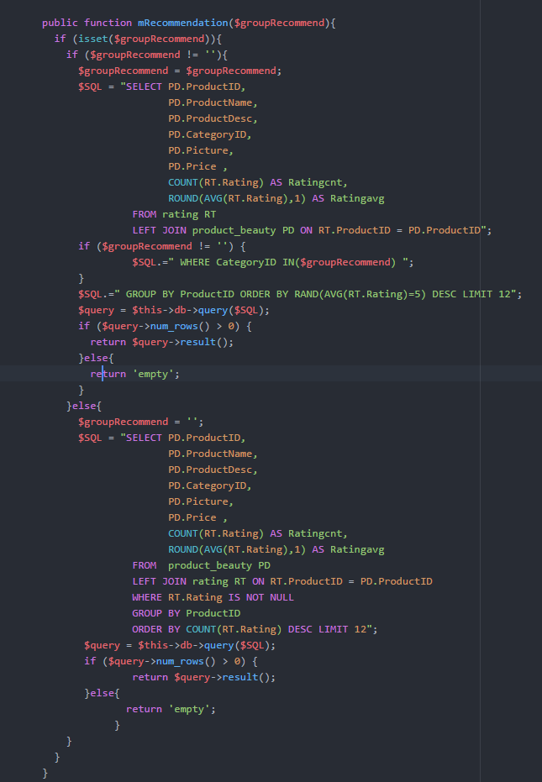

Figure 10: MySQL Statement and PHP Code for Getting Five-Star Rating Products.

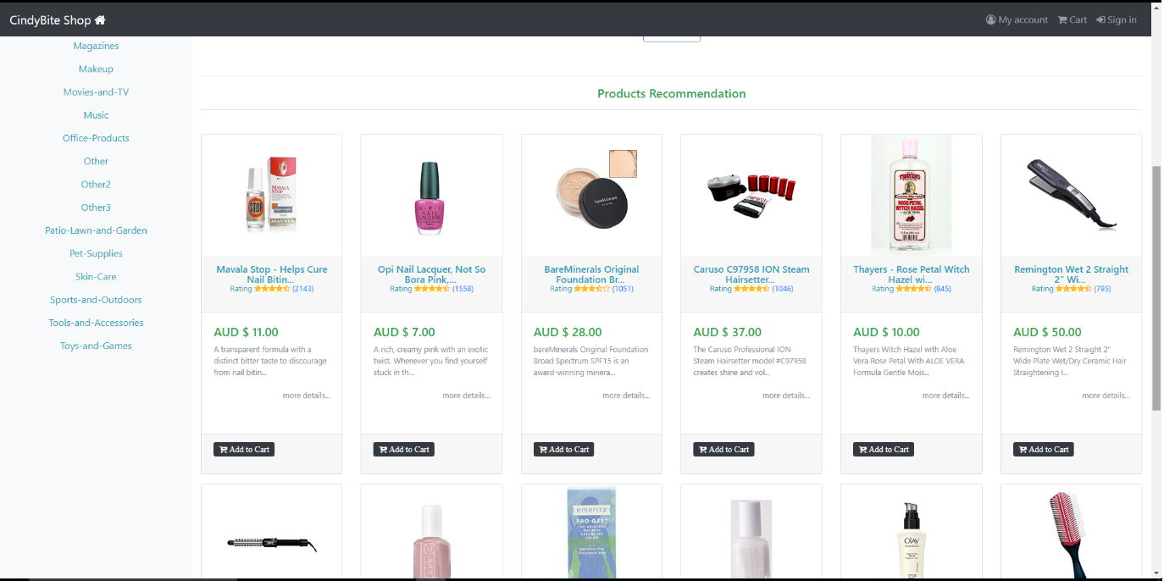

Figure 11: Example of Recommendation products.

## 5.3 Method of testing

In method of development already has some testing which is using XAMPP simulator server in order to keep every on track and fix some bug while working and keep tracking progress of the work by using internet browser to see the result such as Google Chrome, Mozilla Firefox, Internet Explorer. But in this method of testing I used the cloud server to test the prototype by upload prototype to the cloud server called Azure from Microsoft provider, also MySQL is put in the same cloud service.

### 5.3.1 Tools and Instruments

In order to test the prototype on cloud server it need internet connection, internet browser which I use Mozilla Firefox (<https://www.mozilla.org/>), Microsoft account to deploy prototype on cloud service (<https://azure.microsoft.com/>), FTP solution application called FileZilla (<https://filezilla-project.org/>) for transfer prototype file to cloud service.

### 5.3.2 Testing Implementation

Firstly, set up the Azure cloud service before then get all the FTP credential from the Azure cloud website and set up FileZilla with those credential for connecting to cloud service. Before transfer prototype into cloud I have change base URL to cloud URL also database connection to database on cloud. When everything is all set up, prototype files are transfer via FTP in FileZilla application into cloud then the testing procedure is the same as when testing in personal computer that use the simulation server just change from localhost to cloud URL which mine is <http://kunanonp.azurewebsites.net/>.

In order to see the performance and limit of the prototype I use maximum amount of database information that I am able to manage which including:

* 8989 Products.
* 1,048,576 Ratings.

When web site is successful deploy the website is accessible via URL and then implement the functions testing following list below:

* Sign up
* Sign in
* Sign out
* Admin zone
* All button home, my account, cart, add to cart, link to product, etc.
* Add product to cart
* Make a purchase
* Checkout
* Payment
* Purchase history
* Recommendation

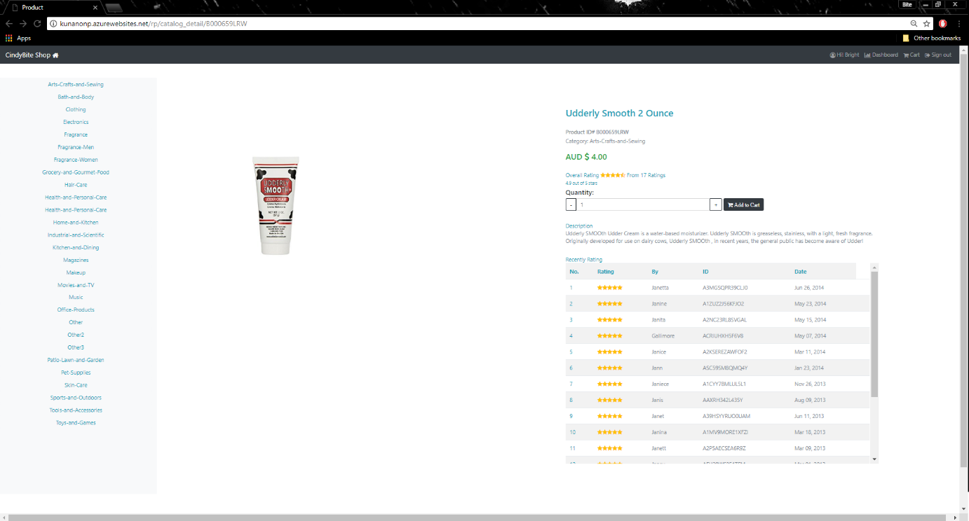

Figure 12: Product Detail Testing.

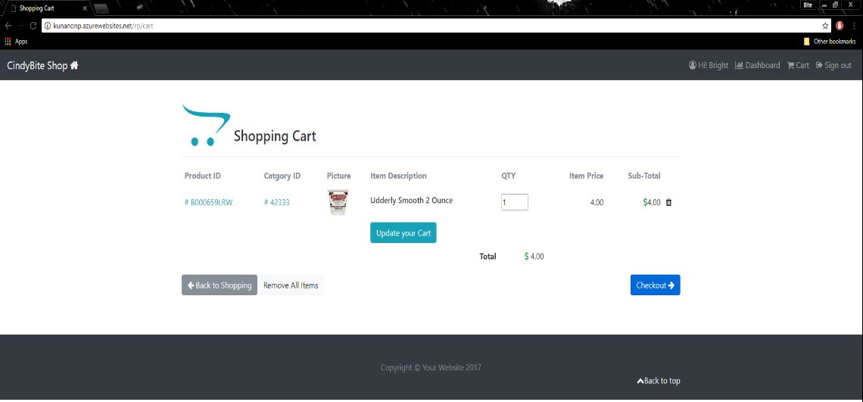

Figure 13: Add Product to Cart Testing.

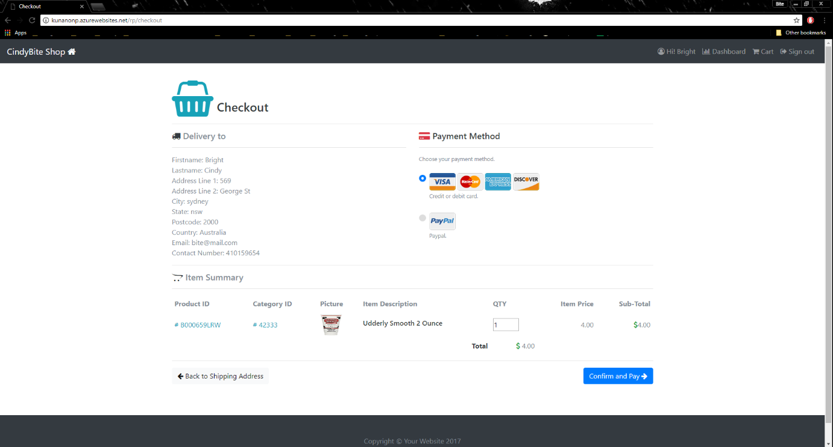

Figure 14: Checkout Testing.

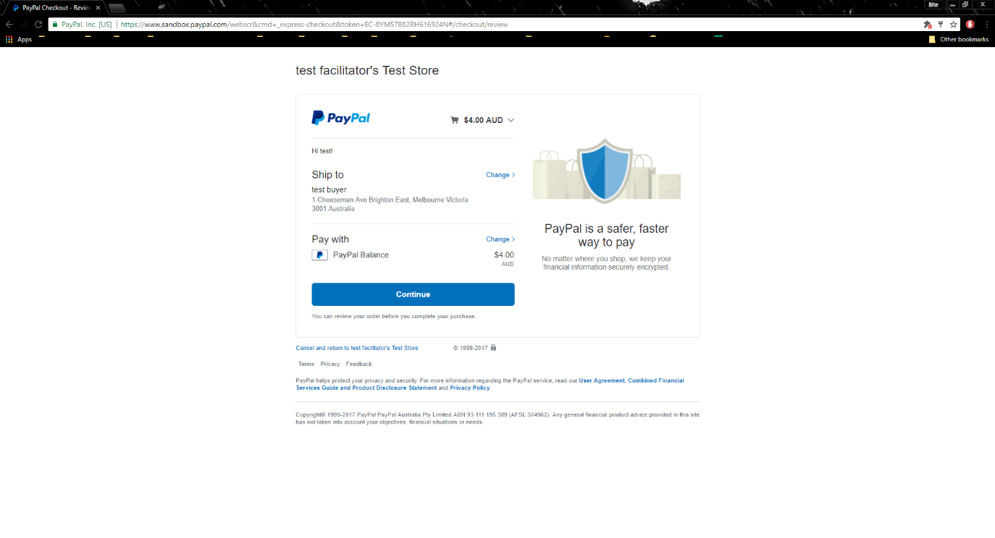

Figure 15: Payment Testing via PayPal Service.

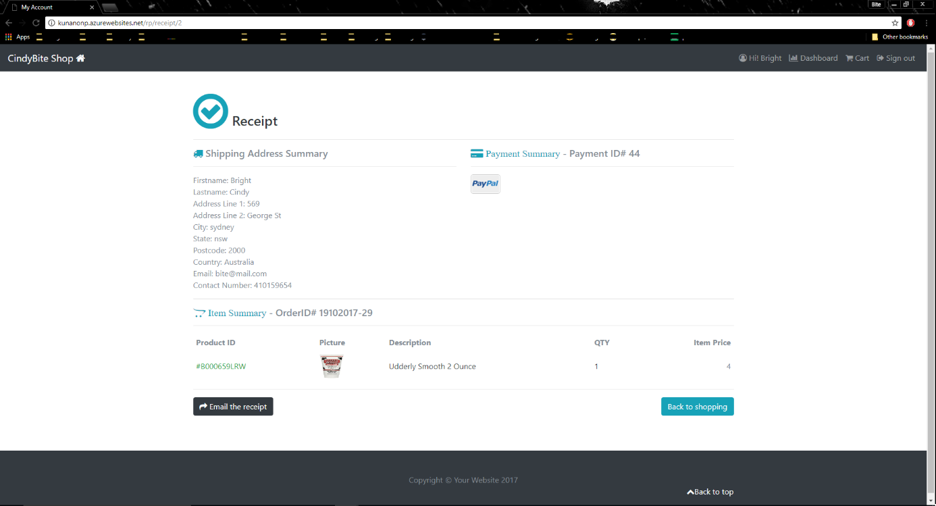

Figure 16: Confirmation Testing.

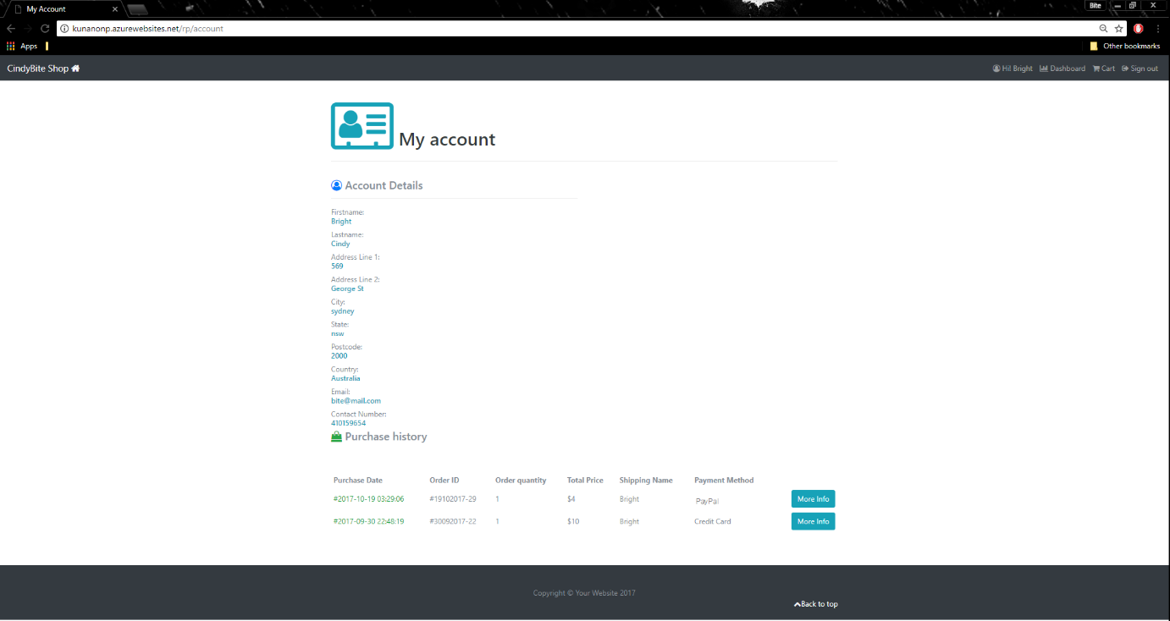

Figure 17: My Account and Purchase History Testing.

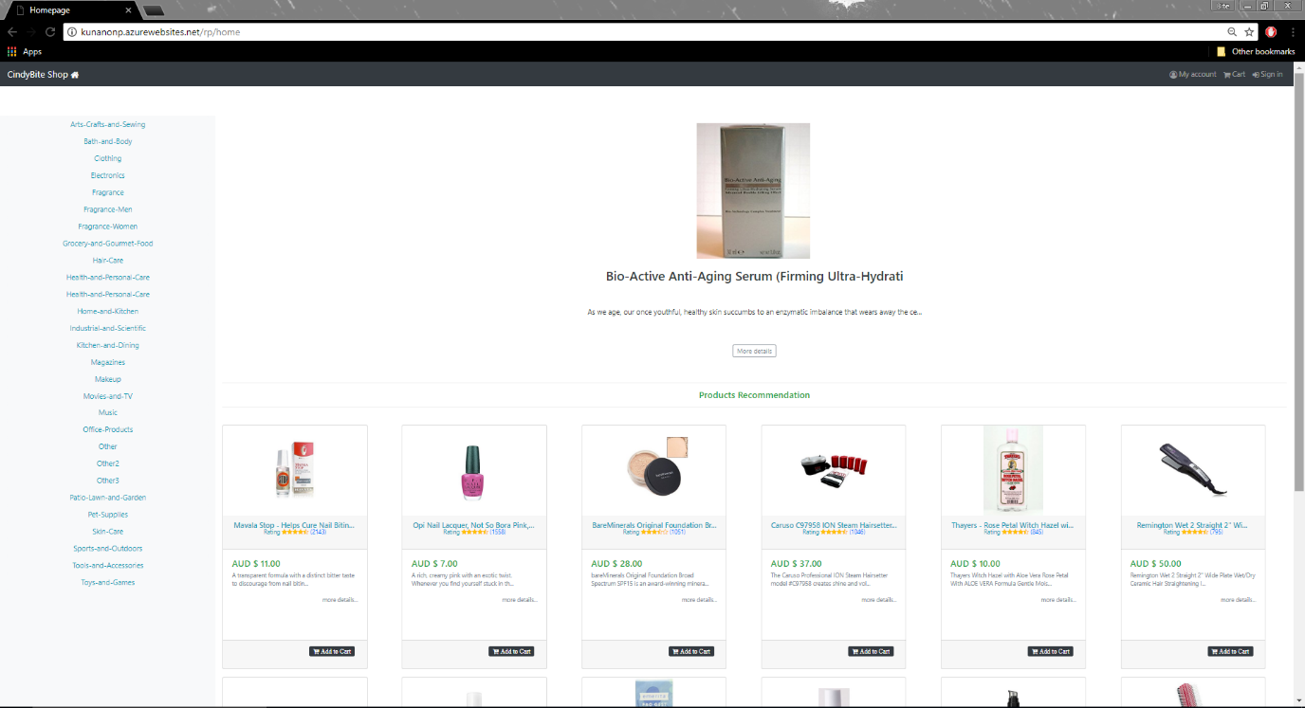

Figure 18: Sign Out Testing.

# 6. Results of testing and Discussion

Prototype of this research project has achieved all the main objectives such as interaction interface design, apply content-based recommendation method, payment method, visualization of order processing method, and store products information in a database.

Interaction interface is designed by considering to be user friendly, consistency to general online retailer web app, and clear visibility, as a result this web app prototype design is able to minimizes the user’s memory load.

Content-based recommendation method is one of the main objective in this research project, the function method is to recommend the product by using purchase history and user’s rating. In this prototype propose these two combinations in order to increase chance of sale and the result it is successfully applied to prototype and it is able to work alongside with web app functions.

Payment method that using sandbox account from PayPal for payment testing, and it represent the well connection between web application and PayPal service. On the other hand, unfortunately that the credit card payment method does not offer any testing service for developer so in this prototype only provide functionality for credit card payment as it can obtain the customer’s credit card details and keep it in the database as a record.

Library cart from CodeIgniter is the main library that is used for visualizing the order processing and destroy cart session after successful payment and order. Finally, all of product information is stored in the database. In this prototype already uses the online database called ClearDB which is a finest MySQL server service from Microsoft Azure.

In conclusion, as mentioned before that this prototype already meets all the requirement and achieve the goals which mean everything provide fully functions. And the result of this prototype propose that the web application performance is depend on amount of database information as mention before in testing method I use 8989 Products and 1,048,576 Ratings to test the performance and outcome is not too surprise which is the web page that represent the product and rating are has some speed issue but still working fine only need to consume more time. On the other hand, when I test with low amount of information performance is in perfect condition. In addition, to mitigate this issue it could be solved in several ways such as decrease the number of information in database, upgrade the server hardware or upgrade the database services which means the following of cost for cloud service.

# 7. Conclusion and Future Work

## 7.1 Conclusion

As a result, this prototype successfully achieves the goals it set before which is to design and develop an online application for retail by apply significant functions that aim to mitigate the issues such as use recommendation system to solve the overload of information on internet issues and in this prototype also enhance this recommendation system which is successfully work together between content-based and user’s rating. In contrast, some factors in this prototype that need some attention such as performance that still limits by hardware requirements in order to provide more efficiency uses.

## 7.2 Future Work

For the future work of this prototype it could be continually apply more recommendation system method such as collaborative which is enhancing the content-based recommendation by connect between the users that has similarity of purchase history instead of use individual purchase history from individual user then suggest the result to other users based on rating and similar user’s preference.

In order to expand more market this prototype could be connected with API such as RESTful API, SOAP API in order to provide service on different platform such as mobile platform e.g. iOS and Android because in mobile application could not directly connect to database but if web app provide API service it could be connect from anywhere not limit to mobile application it means other website that could be a business partner in the future can connect to this web app service by connect to API in order to create user, get information from database, and etc. without redirect to this prototype website.

Moreover, when the website or retail business expands their size it would need more employee or administrators in order to monitor the services, it might need to develop more function e.g. monitor every transaction information, live chat, and etc., in admin zone that currently has basic function such as monitor user information and also administrator could create, edit, and delete user’s account.

# Reference List

Bansal, S. 2015, *Understanding basics of Recommendation Engines (with case study),* Gurgaon, India, viewed 11 August 2017, <<https://www.analyticsvidhya.com/blog/2015/10/recommendation-engines/>>

Hirooka, Y., Terano, T. & Otsuka, Y. 2000 ‘Recommending books of revealed and latent interests in e-commerce’, [*Industrial Electronics Society, 2000. IECON 2000. 26th Annual Conference of the IEEE*](http://ieeexplore.ieee.org.ezproxy.lib.uts.edu.au/xpl/mostRecentIssue.jsp?punumber=7662), IEEE, Nagoya, Japan, pp. 1632-1637.

Hsiao, J. H. & Li, L. J. 2014, ‘On visual similarity based interactive product recommendation for online shopping’, *2014 IEEE International Conference on* [*Image Processing (ICIP),*](http://ieeexplore.ieee.org.ezproxy.lib.uts.edu.au/xpl/mostRecentIssue.jsp?punumber=6992914) IEEE, Paris, France, pp. 3038-3041.

Leskovec, J., Rajaraman, A. & Ullman, J.D. 2014, Mining of Massive Datasets, Palo Alto, CA.

Mathew, P., Kuriakose, B. & Hegde, V. 2016, ‘Book Recommendation System through content based and collaborative filtering method Content-based and collaborative methods’, *International Conference on Data Mining and Advanced Computing (SAPIENCE),* IEEE, Ernakulam, India.

Sato, T., Fujita, M., Kobayashi, M. & Ito, K. 2013 ‘**Recommender system by grasping individual preference and influence from other users**’, *IEEE/ACM International Conference on Advances in Social Networks Analysis and Mining*, [ACM](http://www.acm.org.ezproxy.lib.uts.edu.au/publications) New York, NY, USA, pp. 1345-1351.

Shaikh, S., Rathi, S. & Janrao, P. 2017, ‘Recommendation System in E-Commerce Websites: A Graph Based Approached’, *2017 IEEE 7th International Advance Computing Conference (IACC)*, IEEE, Hyderabad, India, pp. 931-934.

Statista 2017, ​*Retail e-commerce sales worldwide from 2014 to 2021 (in billion U.S. dollars),* view 11 August 2017,

<​https://www.statista.com/statistics/379046/worldwide-retail-e-commerce-sales/​>

Tyagi, R. & Jawdekar, A. 2016, ‘An advanced recommendation system for E-commerce users’, *Symposium on* [*Colossal Data Analysis and Networking (CDAN),*](http://ieeexplore.ieee.org.ezproxy.lib.uts.edu.au/xpl/mostRecentIssue.jsp?punumber=7562831) IEEE, Indore, India.

Uddin, M. N., Shresth, J. & Jo, G. S. 2009, ‘Enhanced Content-Based Filtering Using Diverse Collaborative Prediction for Movie Recommendation’, *First Asian Conference on* [*Intelligent Information and Database Systems, 2009. ACIIDS 2009.*](http://ieeexplore.ieee.org.ezproxy.lib.uts.edu.au/xpl/mostRecentIssue.jsp?punumber=5175945)*,* IEEE, Dong Hoi, Vietnam, pp. 132-137.